I have launched an Amazon Linux EC2 instance and installed Docker, Jenkins,
Apache (httpd), Nginx, and Apache Tomcat on the same server. I configured
each service to run on different ports to avoid conflicts (Jenkins – , Apache
– , Tomcat – , Nginx – ). I updated the necessary configuration
files, started and enabled all services, and opened the required ports in the
security group. Finally, I verified that all services are running and accessible
through the browser.

1.Installing Docker:
First we need to update the packages
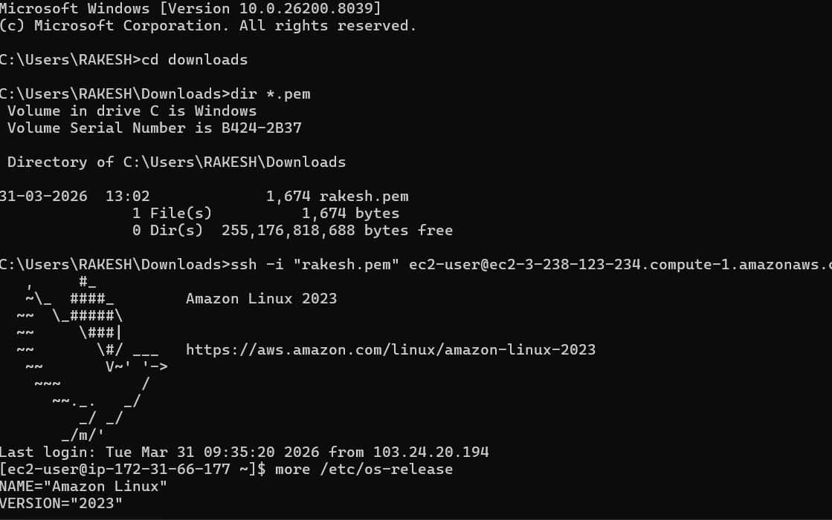

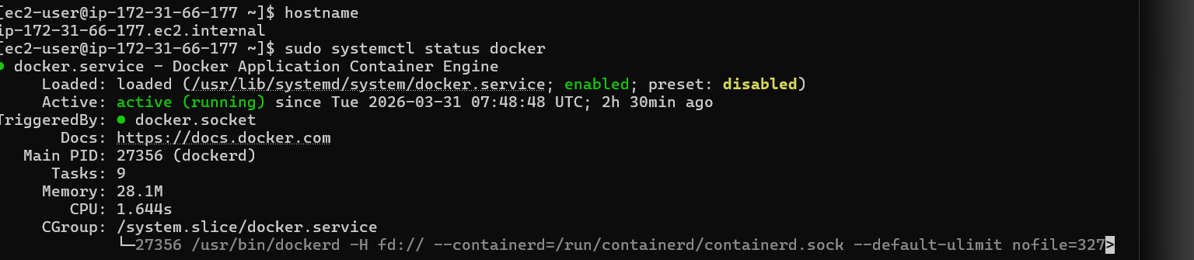
.
yum install is the command to install packages in amazon linux.
Docker is now installed.

2.Installing Jenkins: First, we need to install jave before installing Jenkins

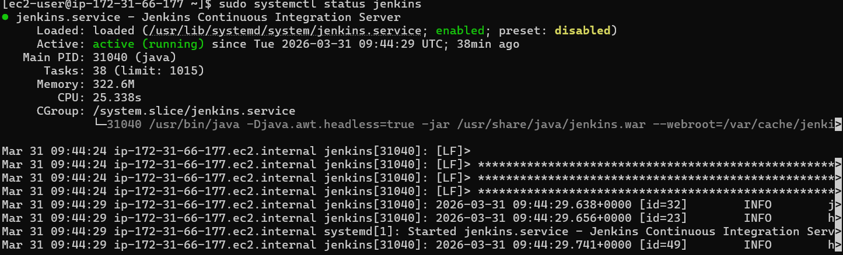

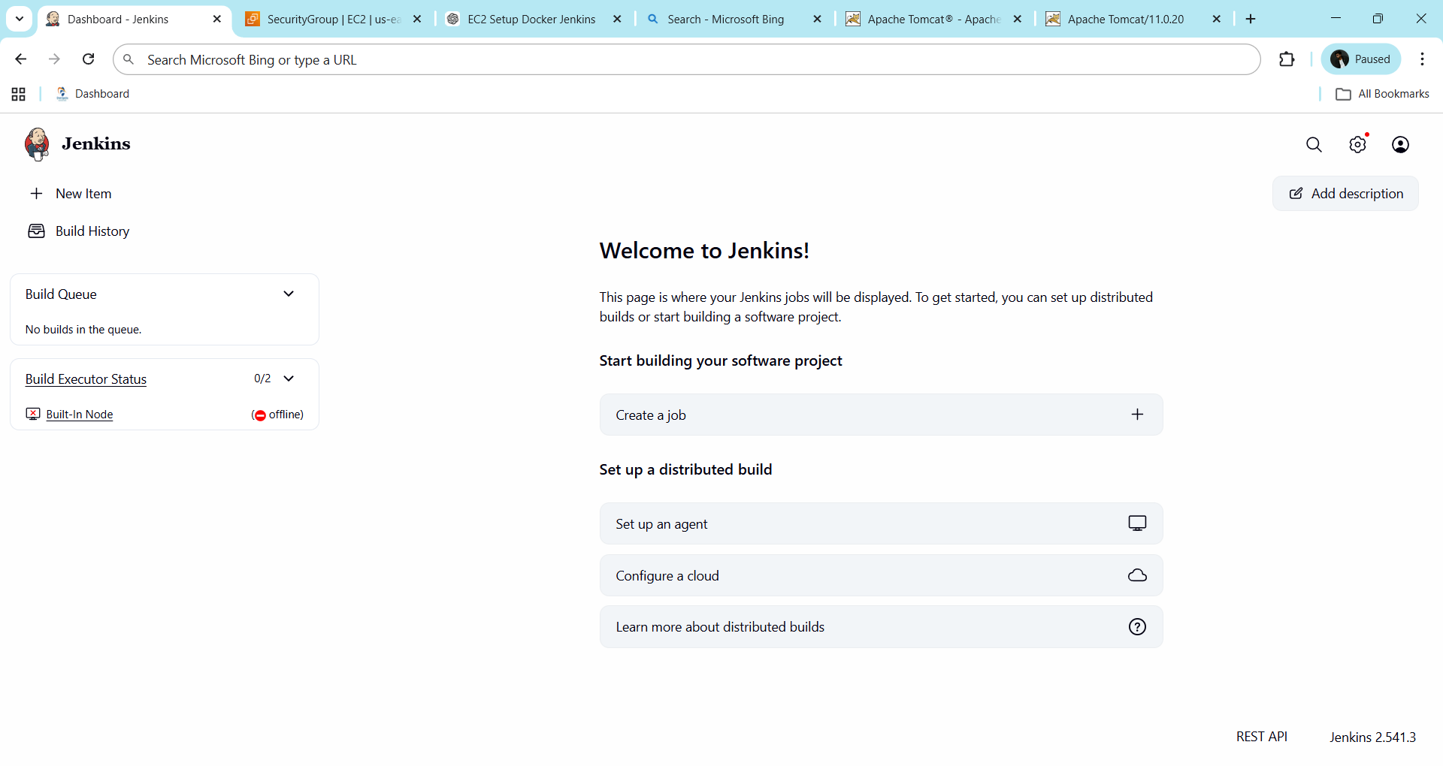
3.Installing Apache(httpd):
Apache (httpd) is now installed
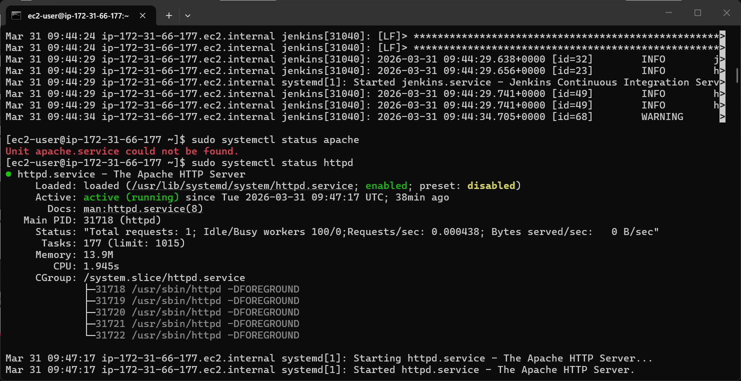

4.Installing Nginx:
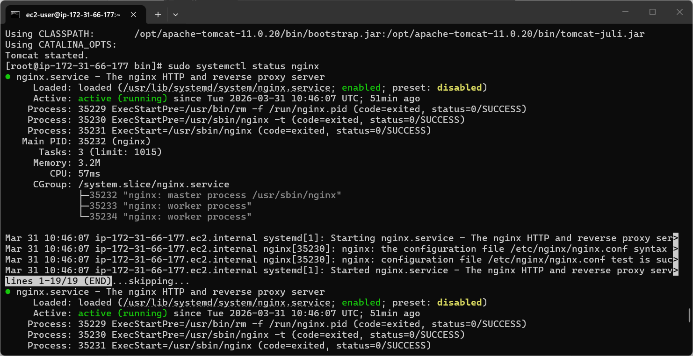
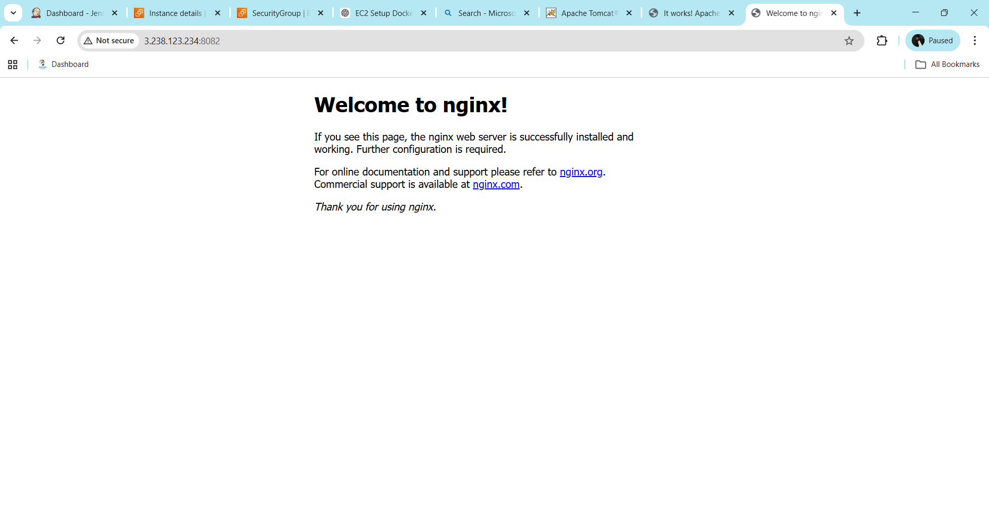
5.Installing Apache tomcat:
First we need to download the package from the internet

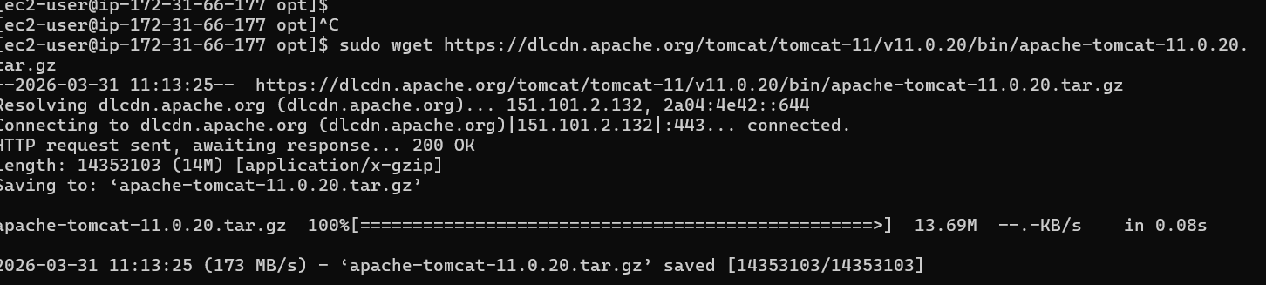
Extracting the downloaded tar file.
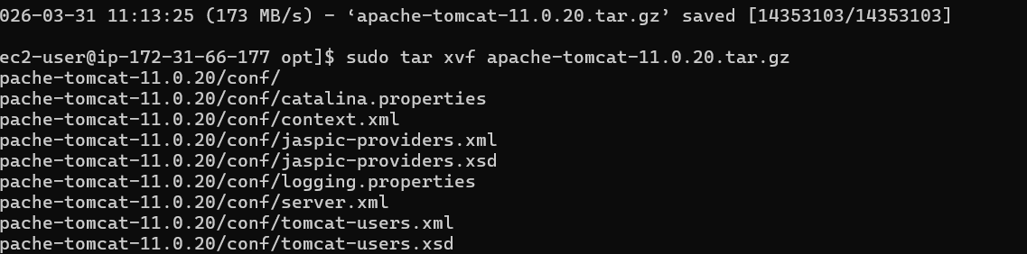
Giving the execute permissions to execute startup script
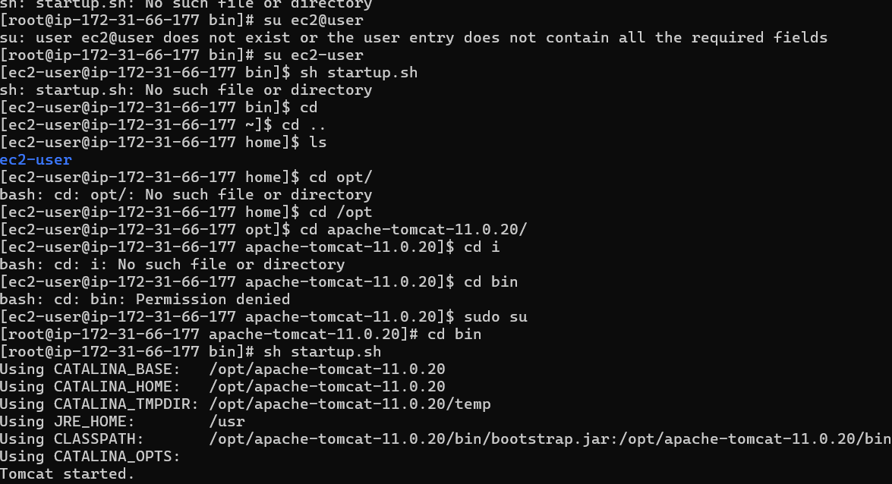
Tomcat server is now running on 8084
